1] Assignment - Using the Python PIP command create a "requirements.txt" file from the Terminal/ Command-Prompt of my system

Before running the cmd
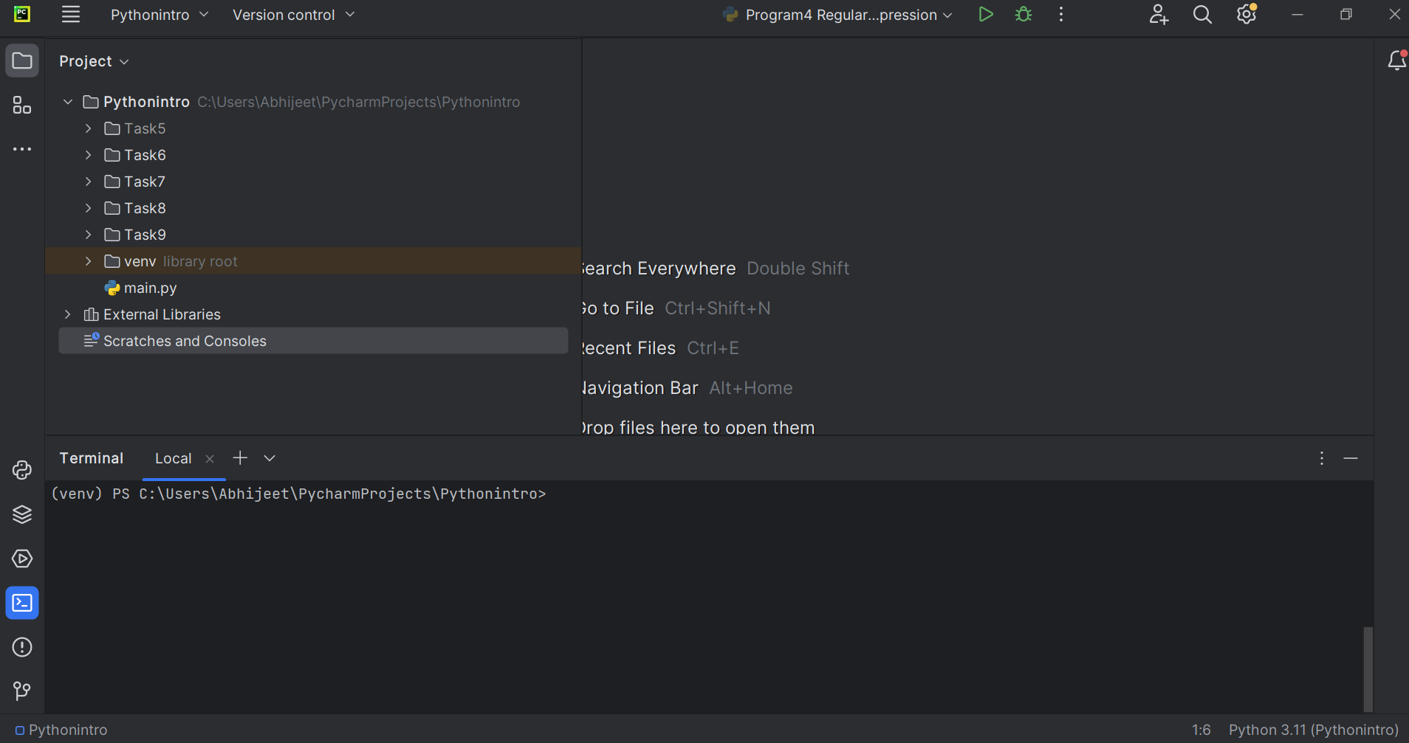
File is created on running the cmd
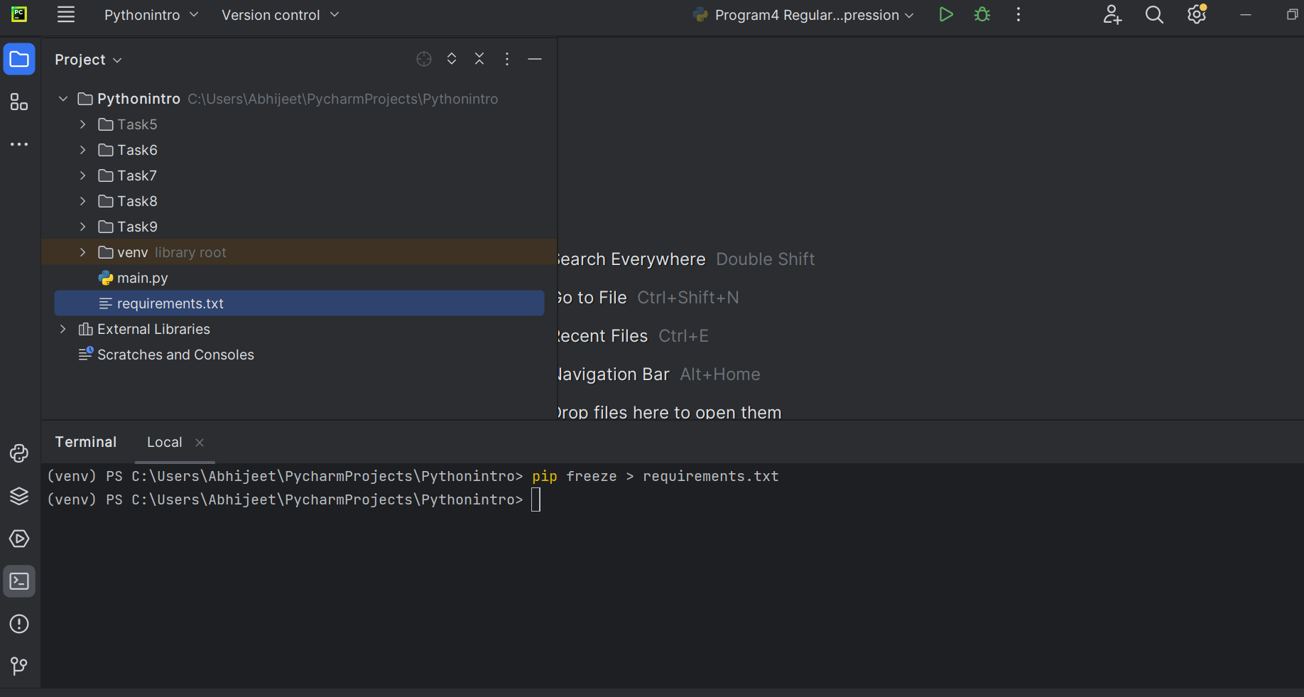

2] Using the python Python PIP command install the Flask module <2.0 into my system
